**Project Report Template**

**CRM APPLICATIONS THAT HEPLS TO BOOK A VISA SLOT**

**1.INTRODUCTION**

**1.1 Overview**

Customer Relationship Management is the best means to reach your customers and serve them in the best way. It automates all those tasks which enterprises used to perform manually. Every organization is set up with some frustrated ambitions and targets. The better the performance of your business, the better will be the relationship with your customers. CRM software Development can turn your business into a powerhouse of sales. Thus, CRM software is no longer essential in fact mandatory for small and medium businesses. Now, you can easily access the CRM software virtually from anywhere and anytime. All you need an internet connection to further the scope of doing your business. So, don’t be late and perform the necessities for implementing the CRM software in your business.

**1.2 Purpose**

A visa slot management project is a system that is used to track and manage the availability of visa slots, which are appointments that are required for certain visa applications. It might be used by a government agency or a visa processing center to schedule and manage appointments with applicants.

**2. Problem Definition & Design Thinking**

**2.1 Empathy Map**

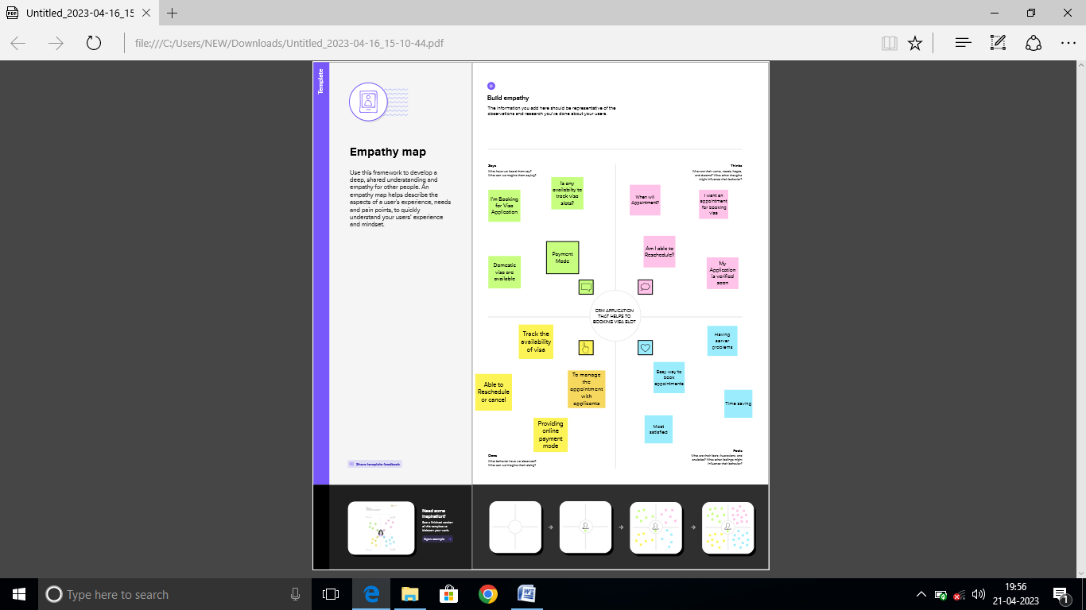

**2.2 Ideation and Brainstorming Map**

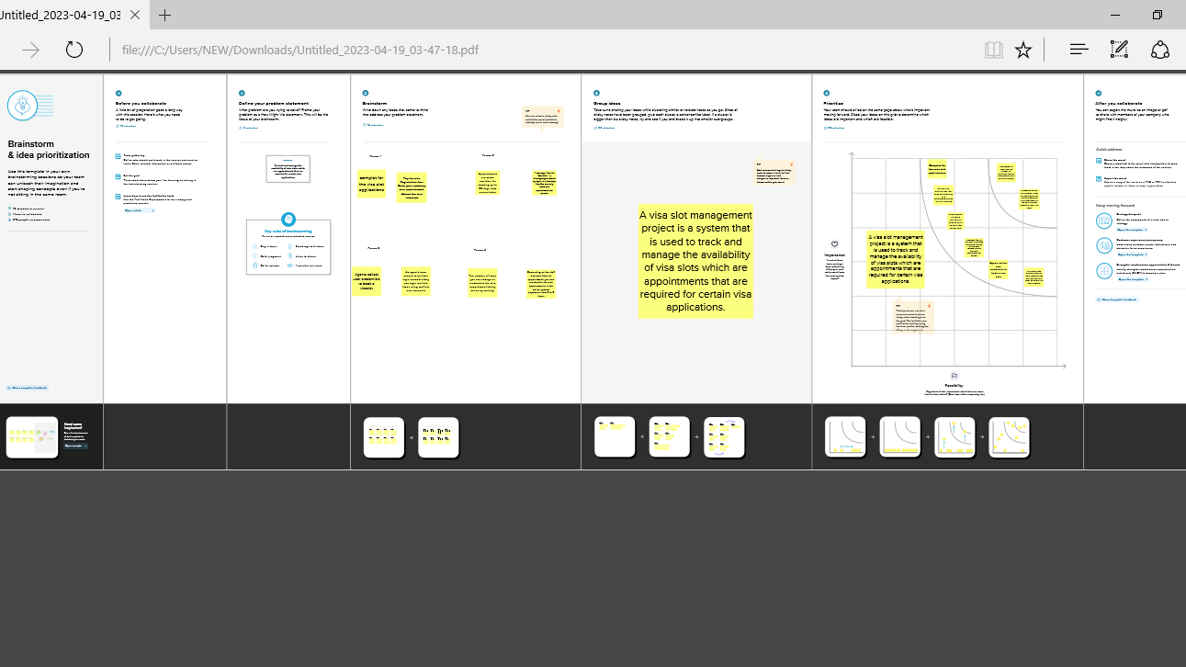

**3 Result**

**3.1 Data Model**

|  |  |
| --- | --- |
| **Object name** | Foelds in the Object |
| **Obj1** | |  |  | | --- | --- | | Field Lable | Data type | | Passport | Text | |
| **Obj2** | |  |  | | --- | --- | | Field Lable | Data type | | Visa slots | Text | |

**Activity & Screenshot:**

**Milestone 1 –Salesforce:**

**Activity1:**

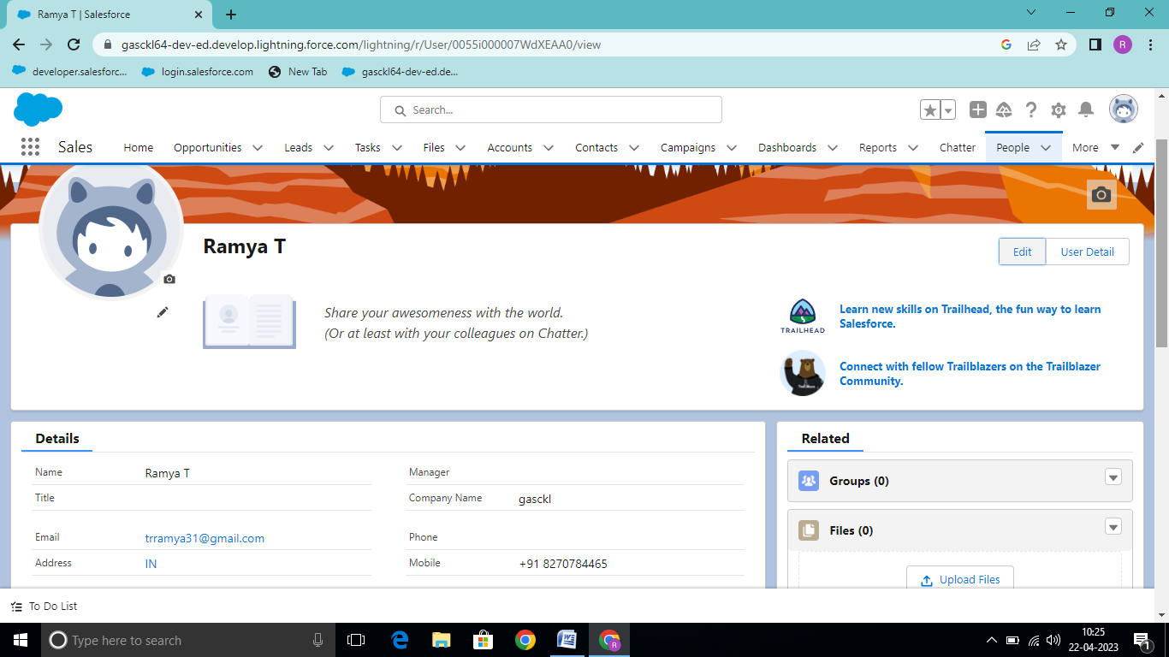

**Milestone -2 : Object:**

**Activity-1:**

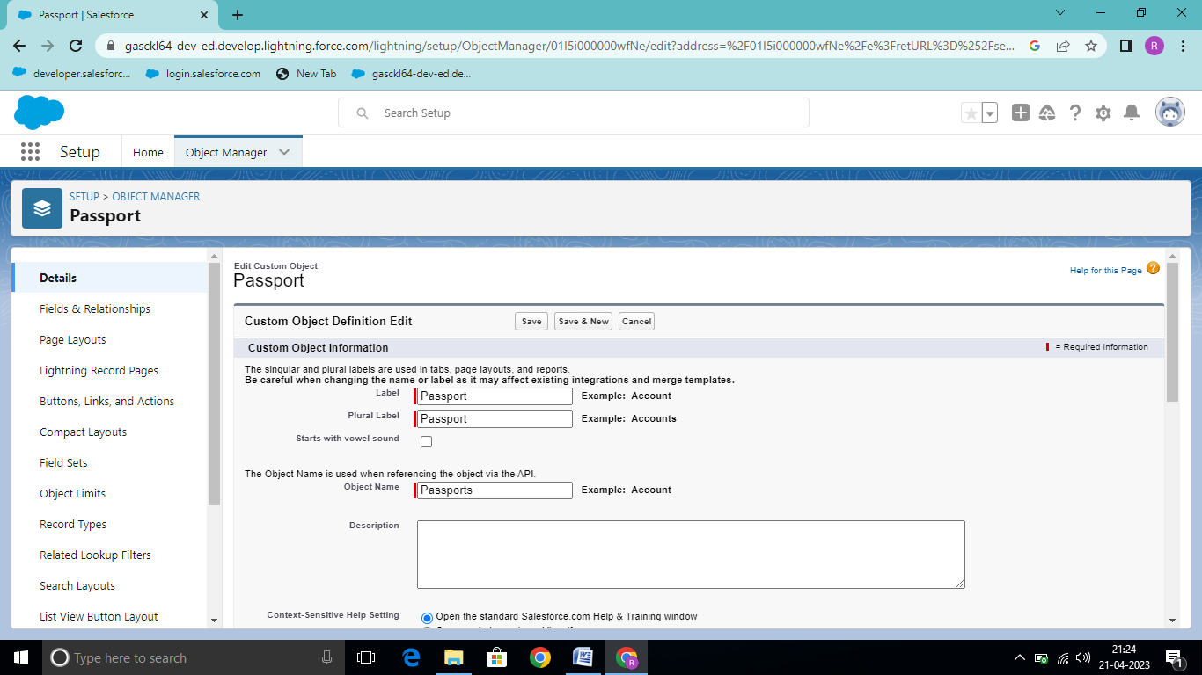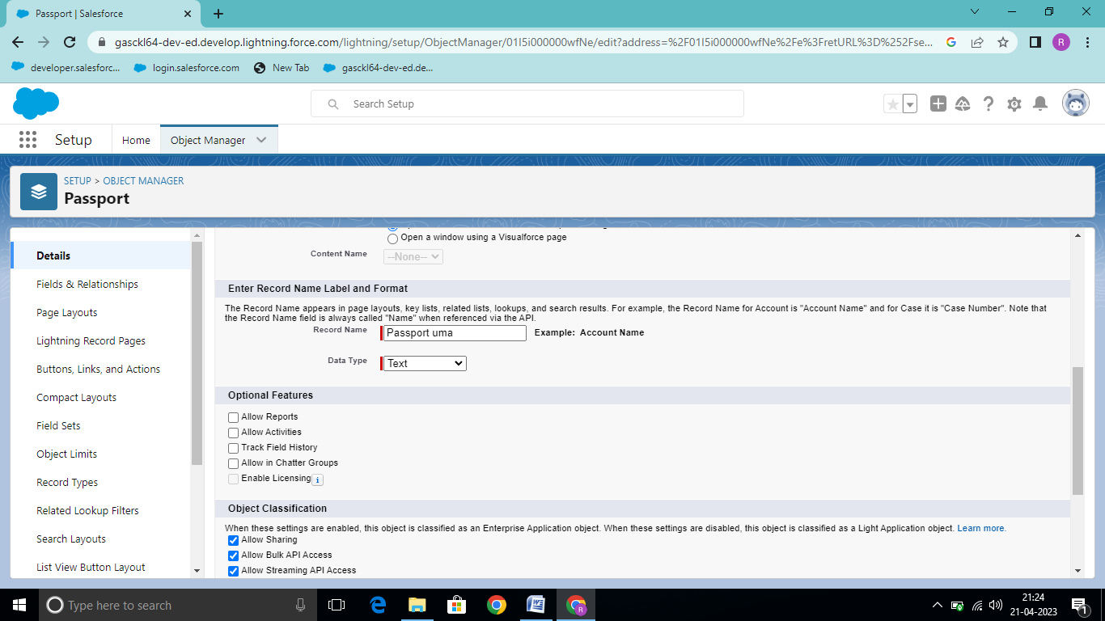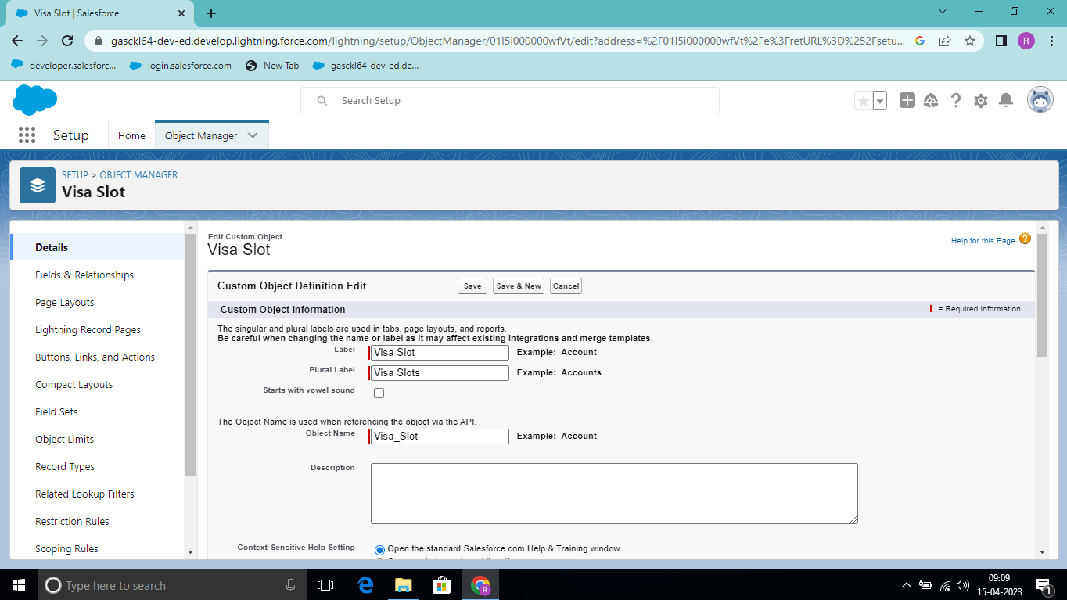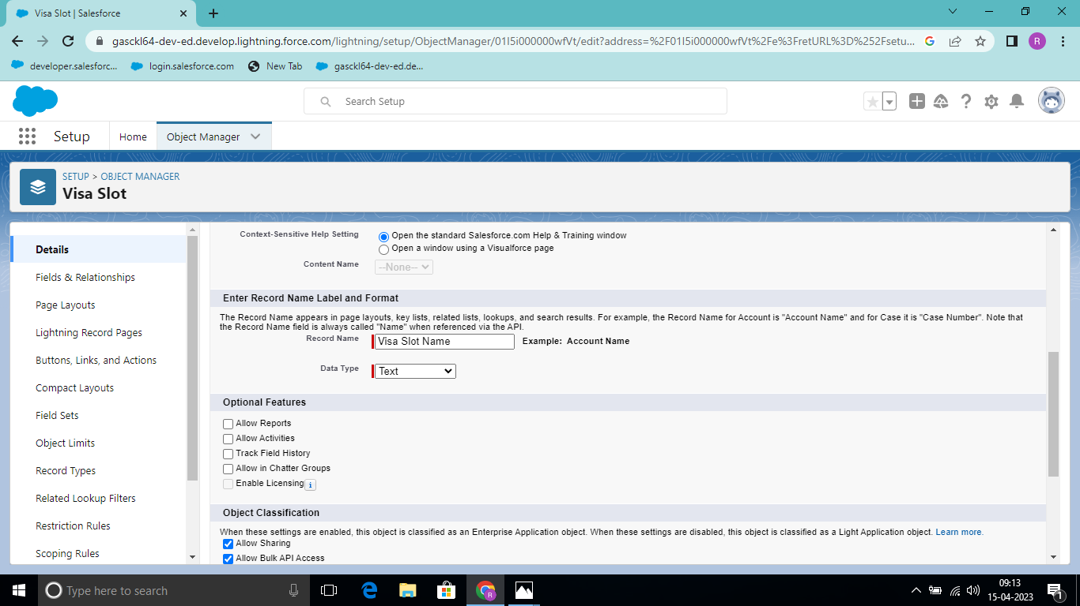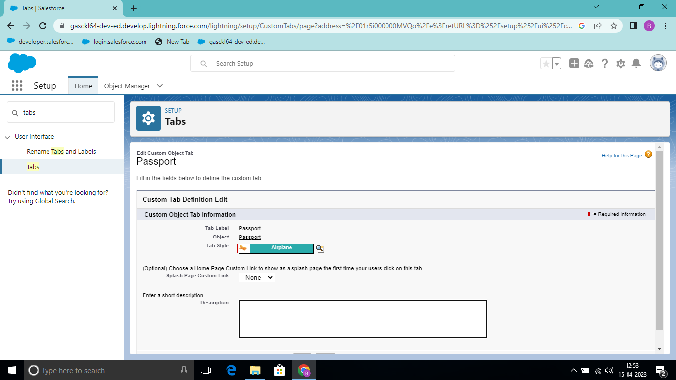

**Activity-2:**

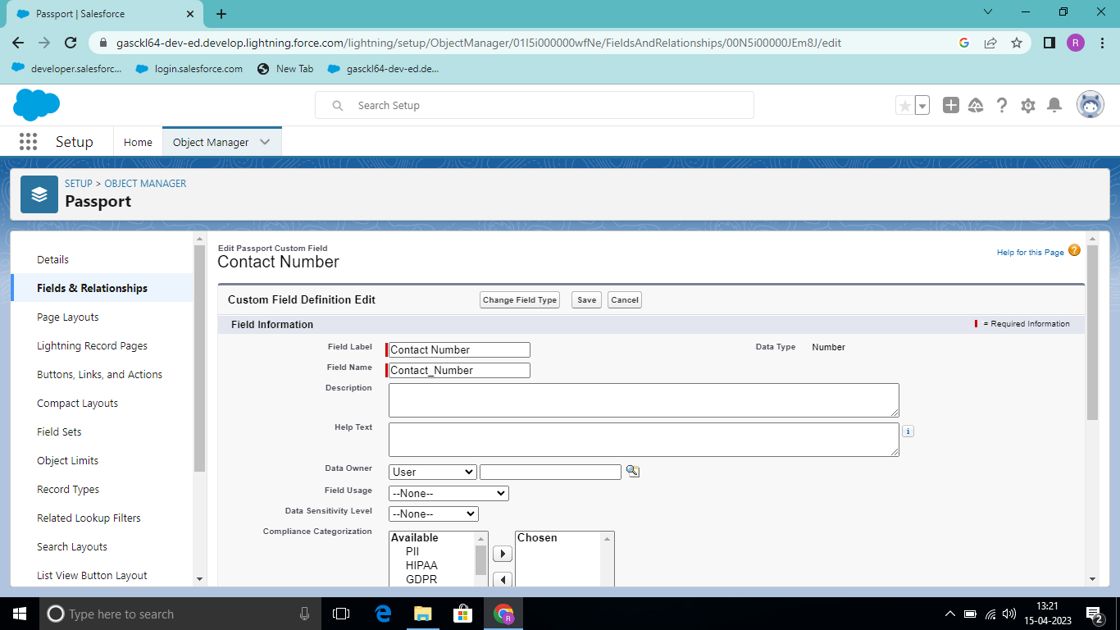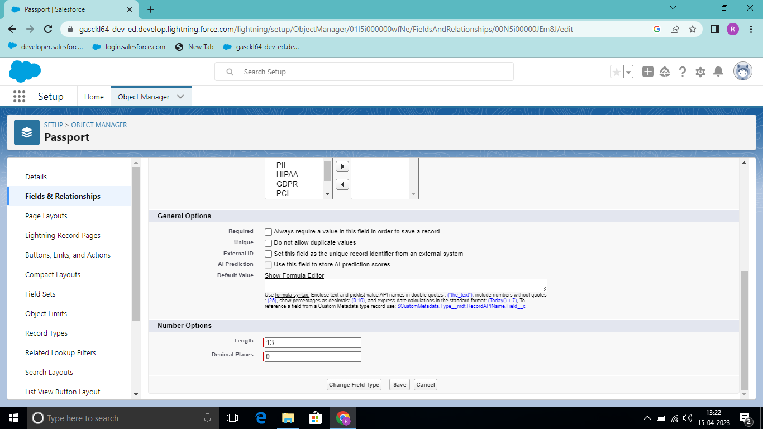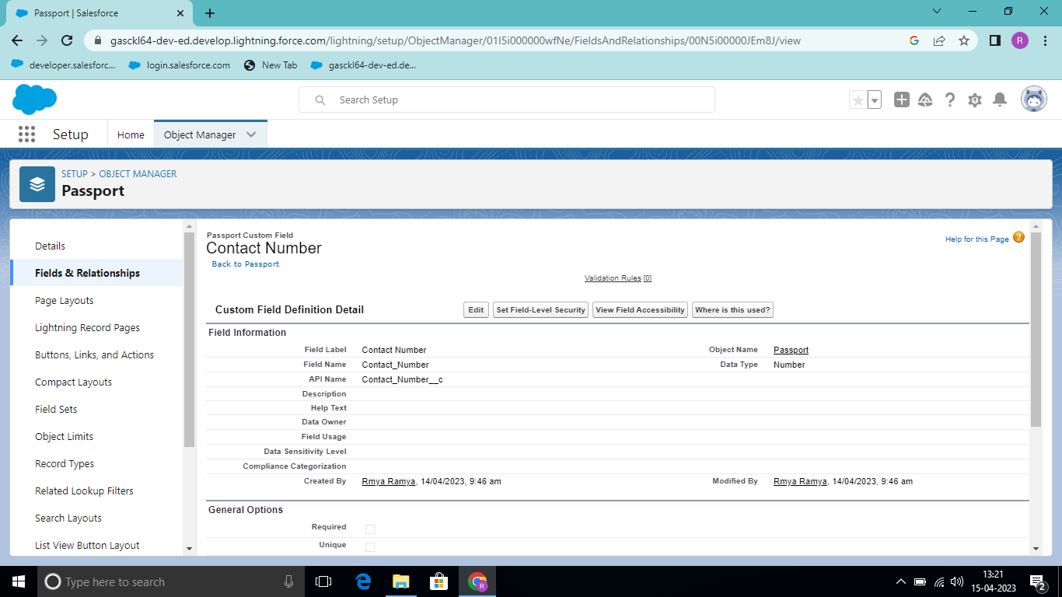

**Milestone-3: Relationship B/w Objects**:

**Activity1:**

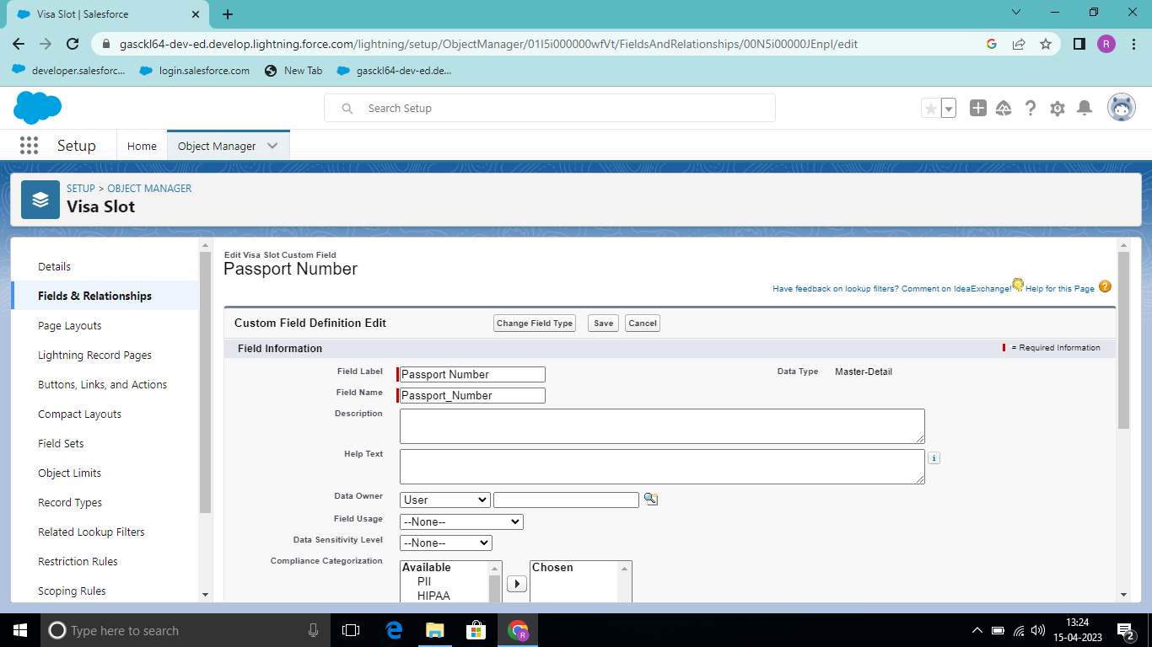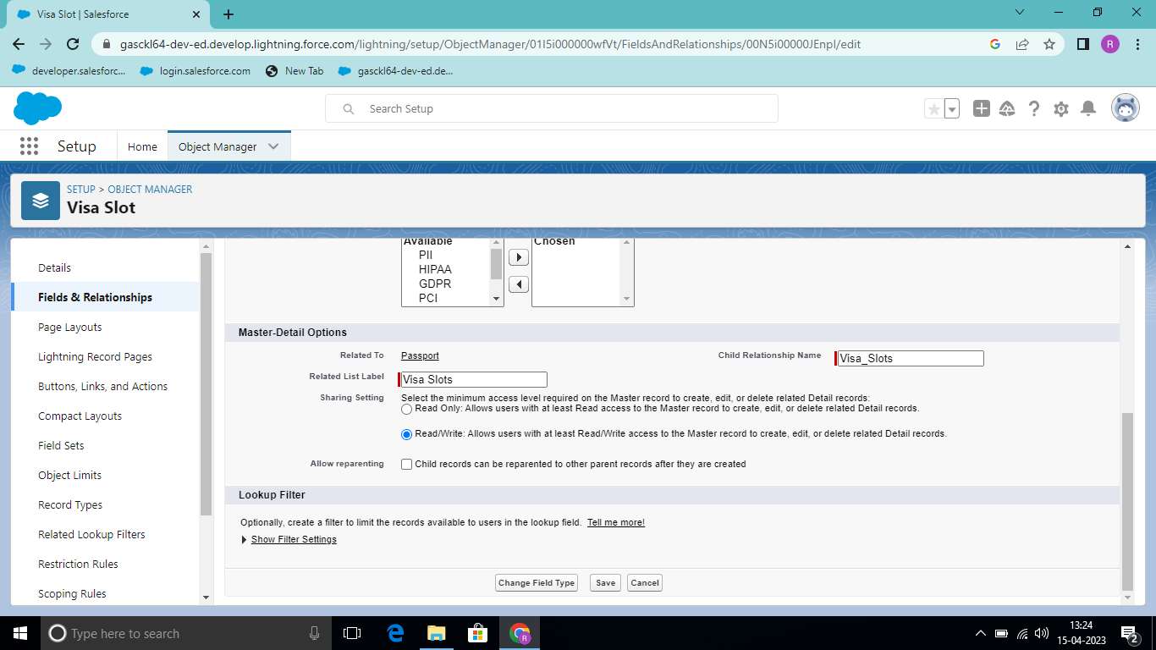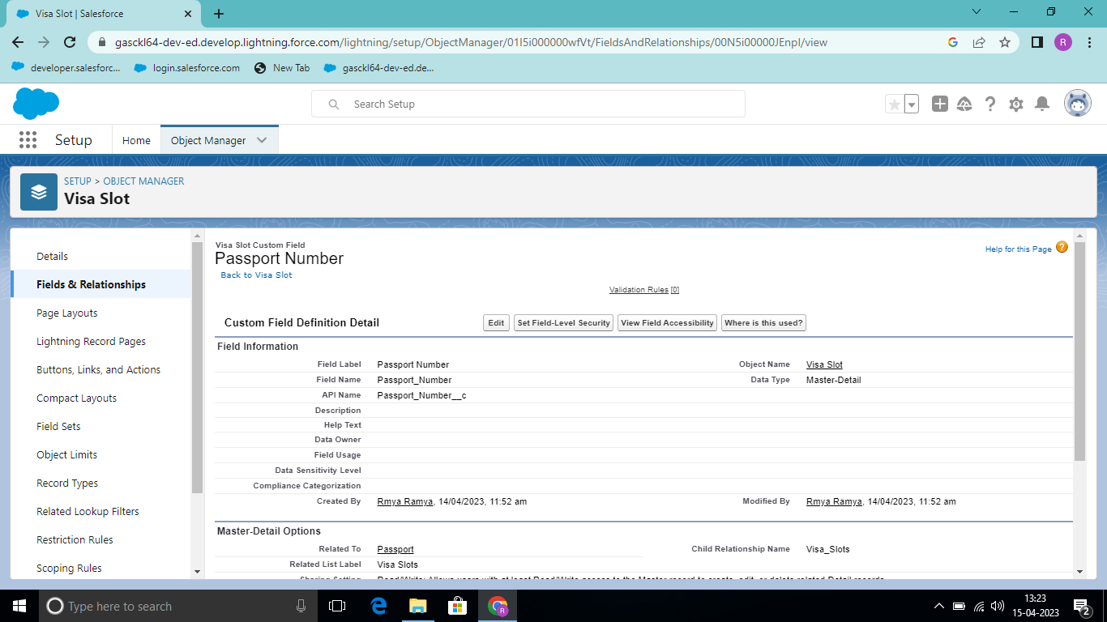

**Milestone-4 App**:

**Activity1:**

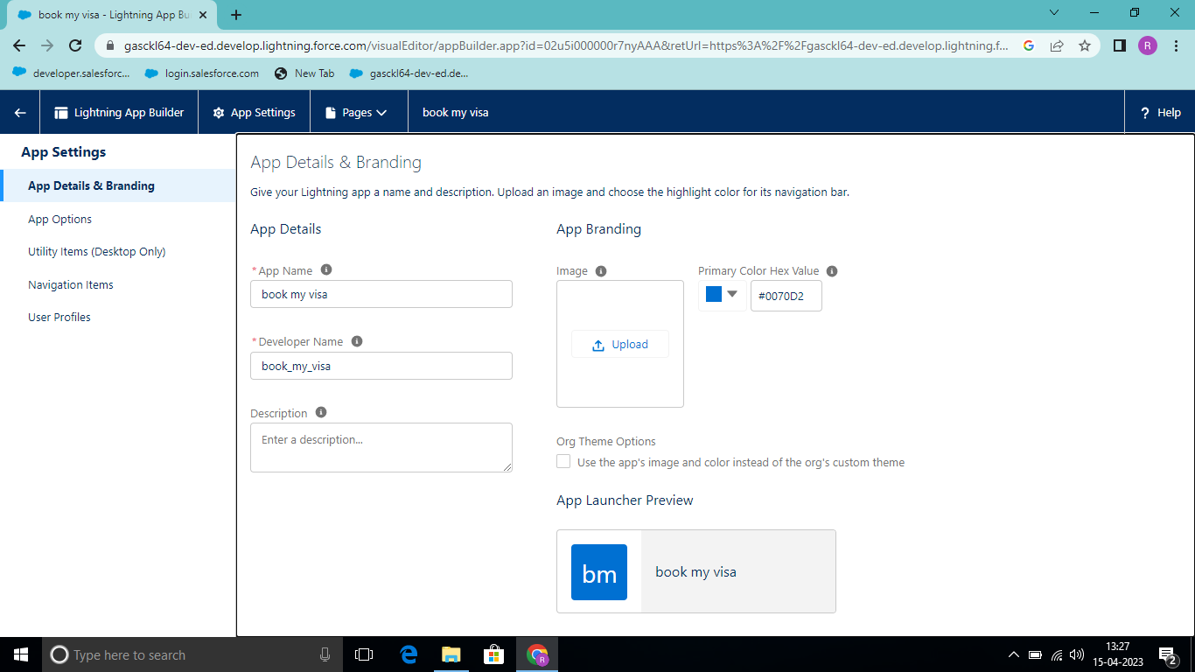

**Milestone -5: User:**

**Activity1:**

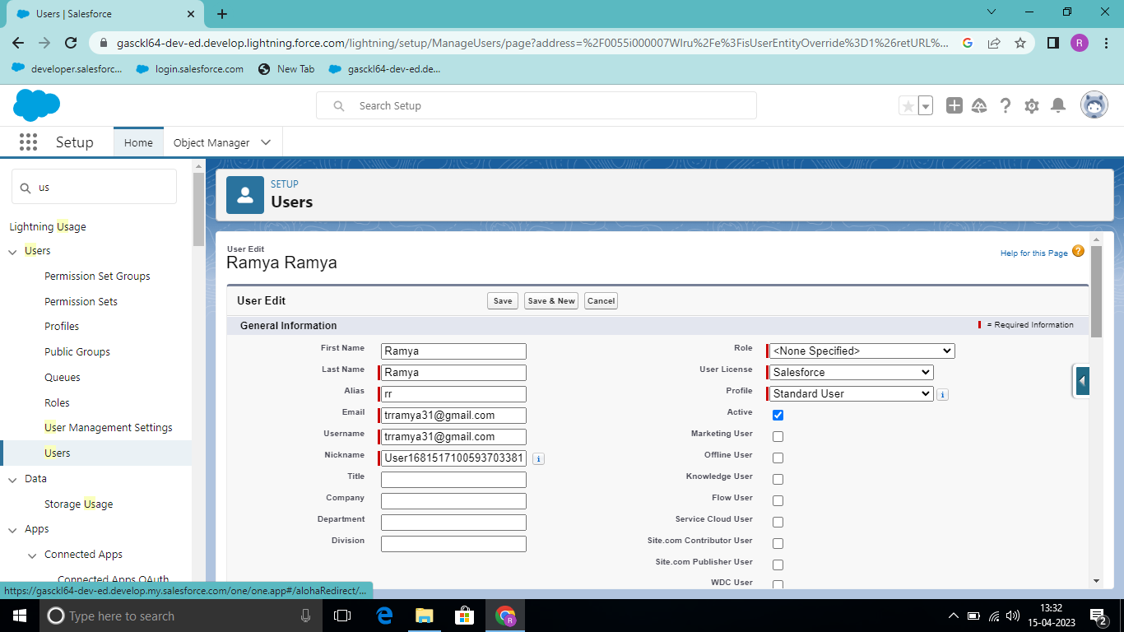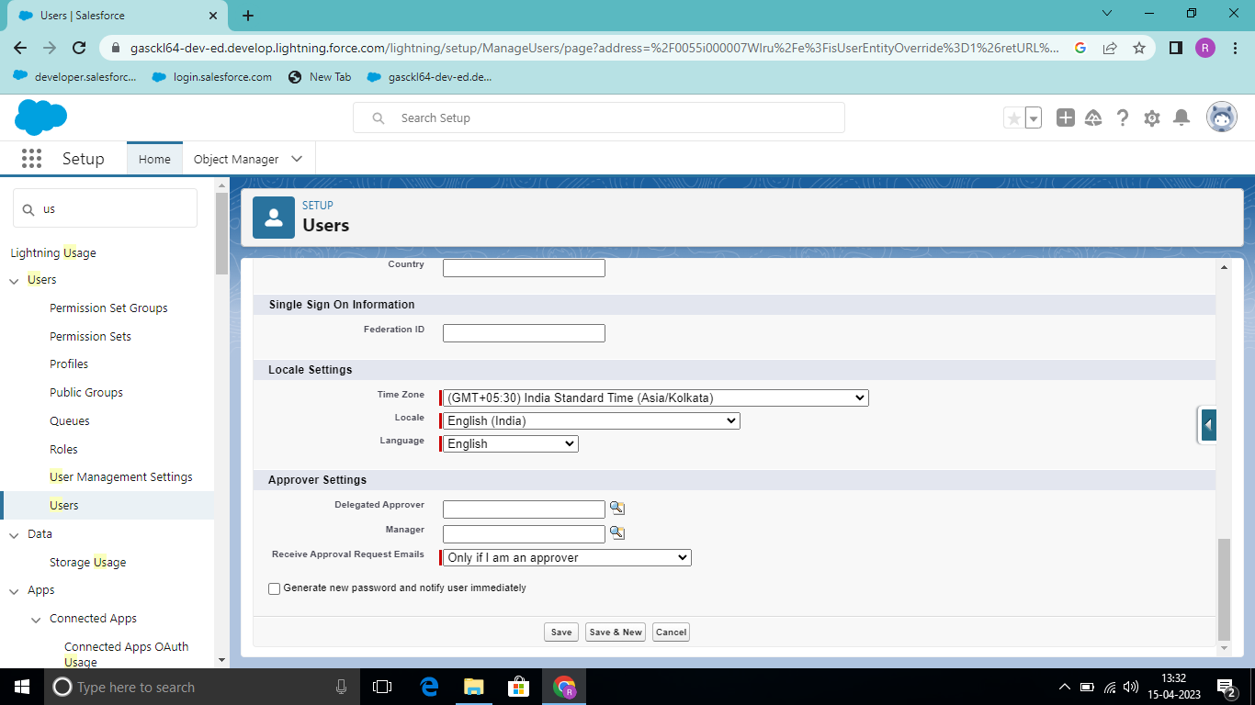

**Activity-2:**

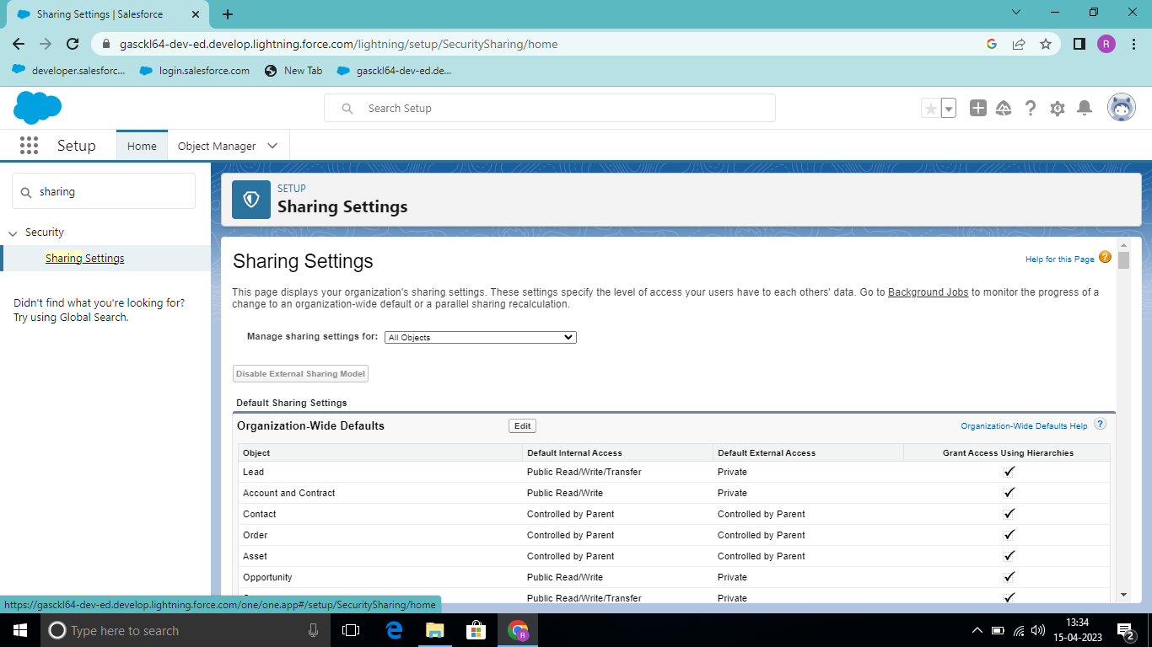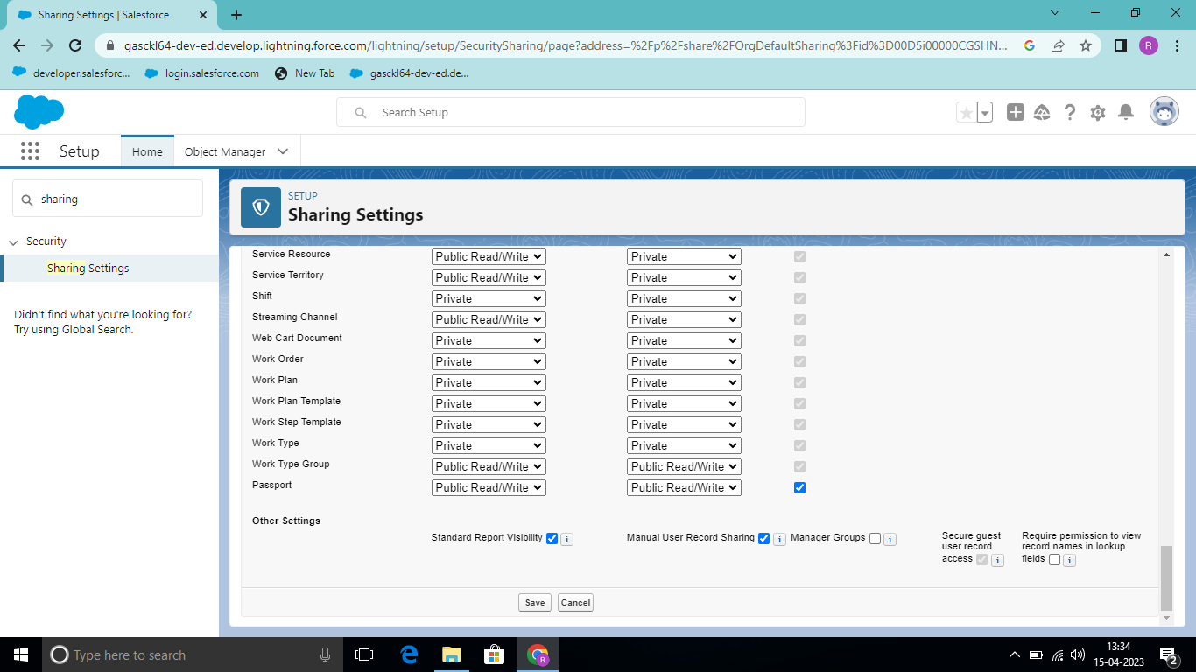

**Milestone -6: Reports:**

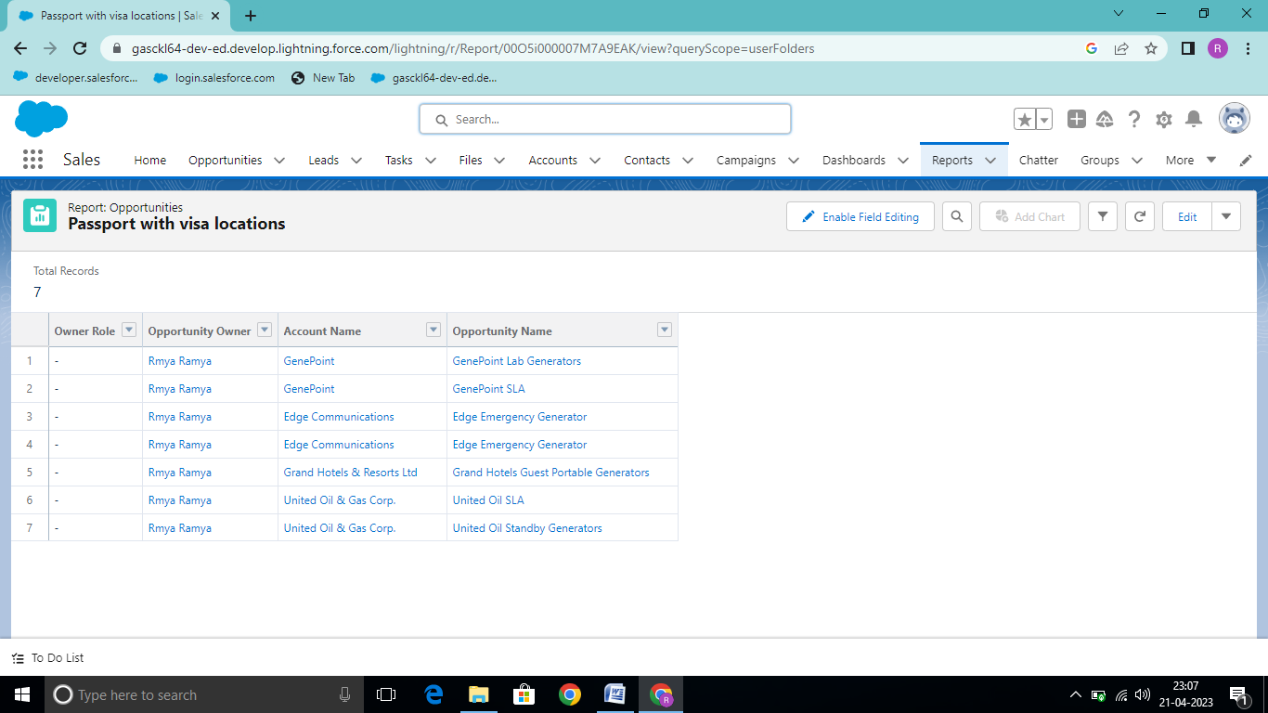

**Milestone-7; Dashboards**:

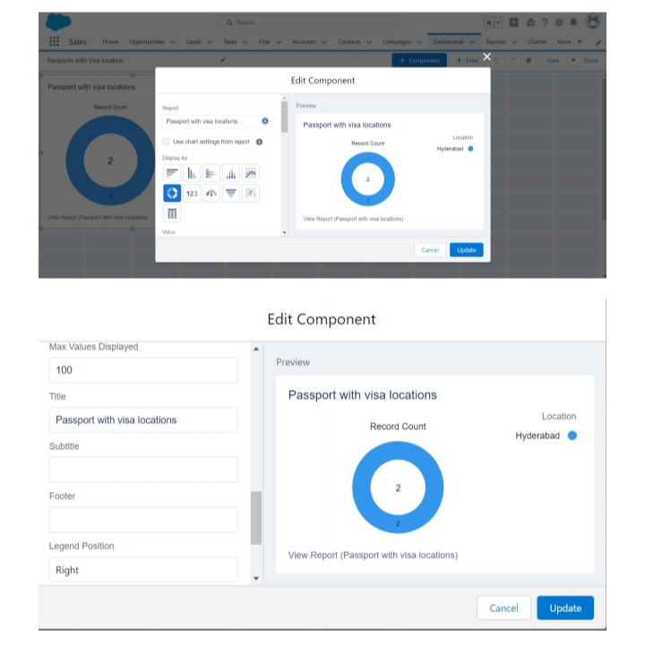

**4 Tailhead Profile Public URL**

**Team Lead**  – <https://trailblazer.me/id/trramya31>

Team Member1 – <https://trailblazer.me/id/moniram0117>

Team Member2 – <https://trailblazer.me/id/mdevi200>

Team Member3 – <https://trailblazer.me/id/kd344879>

Team Member 4– <https://trailblazer.me/id/elaiyaraja811>

1. **ADVANTAGES & DISADVANTAGE**

**\*ADVANTHGES**

* Stress free,hustle free booking of tickets.

* Easy payment options.
* Various additional schemes to avail on dis booking.. sply when u have an account of site frm where u r ding booking.
* You can have various options while choosing ur tickets.

**\* DISADVANTAGE**

* Softwere glitch can cause u buy same ticket twice.. And den u have to contact Cust care and stress urself for reversel.

1. **APPLICATIONS**

* Knowing The availability of visa slots neccessary for some visa applications.
* Tracking and managing the Visa applications.
* Planning and supervising with applicants.
* Government agency or any Visa Processing centres can use this module to manage the appointments with applicants.

1. **CONCLUSION**

* In this project, I have explained about the topic 'CRM Application that helps to book a visa slot' by providing full datails on it.
* This project also emphasizes on mail ideas related to the topic.
* I wish this project will be a useful and the knowledgeable one.
* At last I would like to share my exprience while doingthis project.

1. **FUTURE SCOPE**

. These passport of the future will most likely take the from of a digital idental that's cryptogaphically sealed on the bolckchain, a secure decentrailized leder, and accessed via a unique digital fingerprint. This means fast and more convenient immigrations, plus on chance of that or forger.

THANK YOU